Congratulations on purchasing the Multi-Face Clown Trash Can Pop-up Prop.
We tried to build our product as intuitive as possible, but hopefully you'll find the instructions here clear, simple, and easy to follow. If you don't, please feel free to read them again, but more slowly.
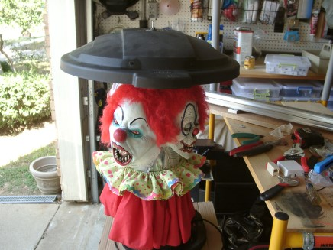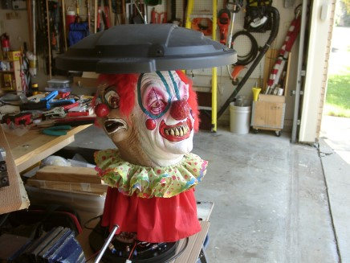

Set UP

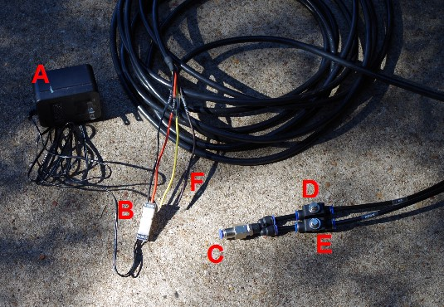
1} Connect transformer (A) to the Prop wiring harness connection (B) and plug the transforming into a 110V AC outlet (i.e. plug it into the wall or an extension cord).
2} Connect a compressed air source to the Prop air fitting (C) using ¼ inch diameter air tubing.
3} Adjust the speed of the pop-up using the UP speed control (D).
4} Adjust the volume of the air horn using the HORN speed control (E). Note: the volume can be adjusted from off to ear bleeding.
5} (optional) Connect the Orange (positive) and Brown (negative) speaker wires to an audio source. The audio will be audible in scare mode and mute when the prop is at rest.

Prop Operation
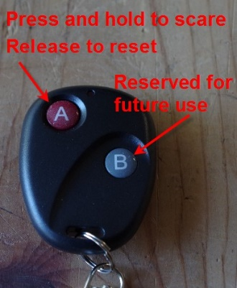
INSIDE THE CAN
The Clown Prop can be extracted from the can by removing the three retaining screws located at the bottom of the can.
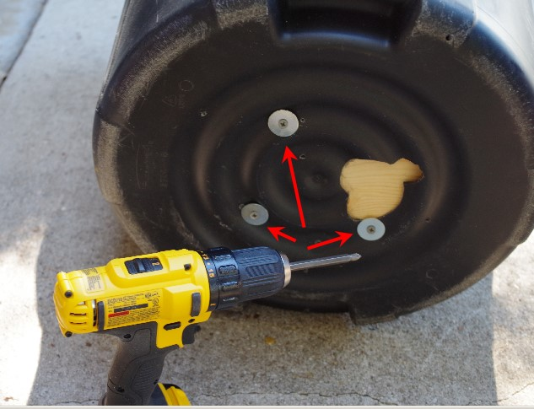

Prop components:
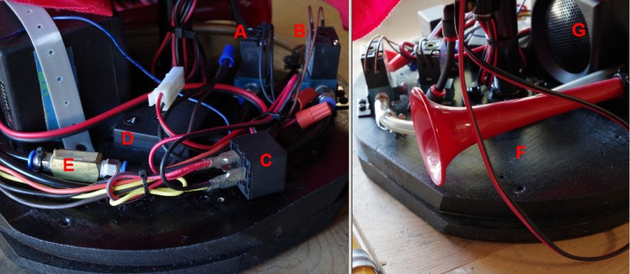
- Pop-up Air Valve.
- Horn Air Valve.
- Audio Relay.
- Remote Relay Receiver.
- Horn Air Back Flow Restrictor.
- Air Horn.
- Audio Speaker.

